# **Lab 14: Web Design Application – AI-Assisted HTML/CSS/JS Generation**

**Name:** Suhana Rehan

**Enrollment Number**: 2503A51L36

**Assignment Number:**14.4

**Task 1: Responsive Web Page Layout**

**Prompt:**

Generate HTML and CSS for a responsive web page with a header, main content, and footer that works on desktop, tablet, and mobile.

**Code:**

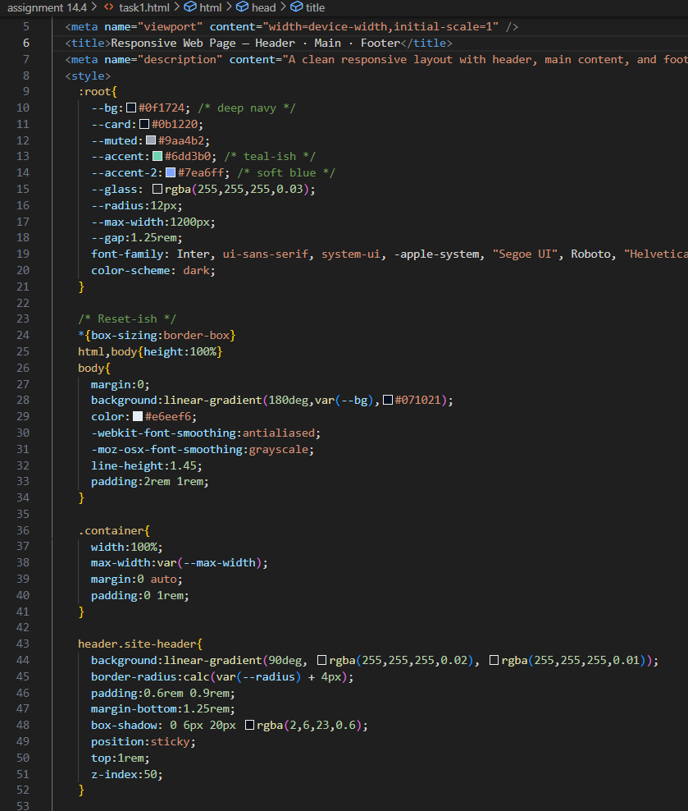

**Output:**

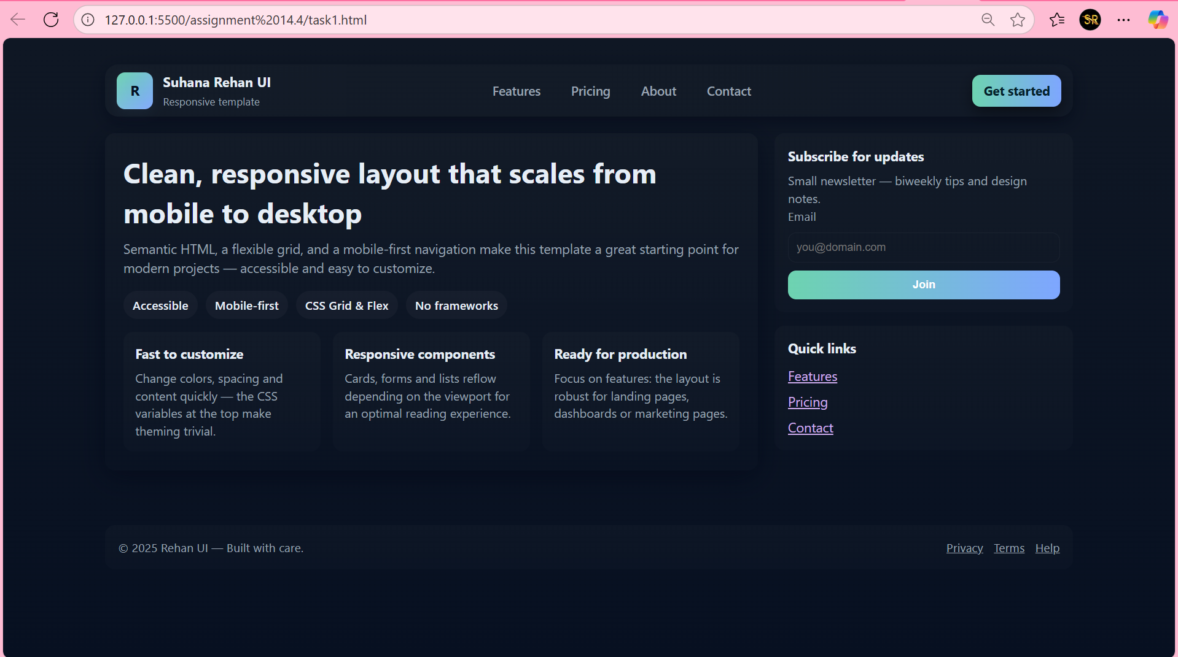

**Observation:**

* The layout looks neat and changes size smoothly on different screens.
* I learned how CSS media queries help in making pages responsive.
* It feels cool to see the same site fit my phone and laptop perfectly.

**Task 2: Interactive Button with JavaScript**

**Prompt:**

Write JavaScript code that shows an alert message when a button is clicked, with comments explaining each step.

**Code:**

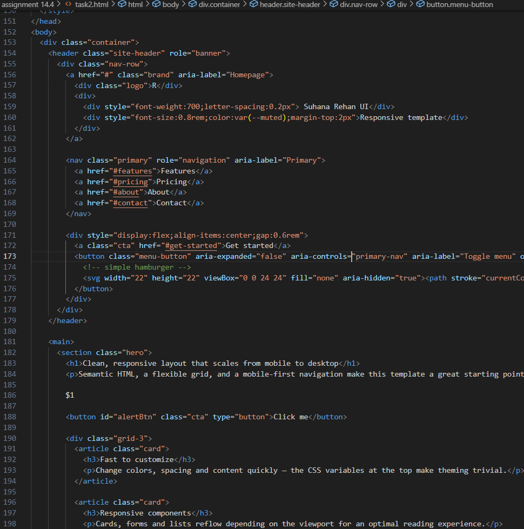

**Output:**

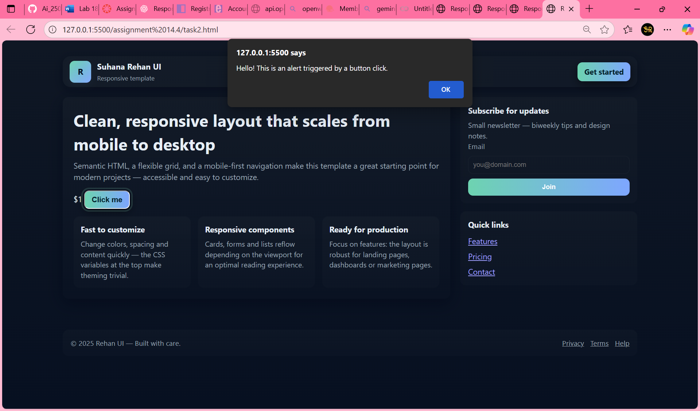

**Observation:**

* The button actually reacts when I click it , that’s fun!
* JavaScript makes web pages feel alive and interactive.
* I understood how addEventListener connects HTML and JS actions.

**Task 3: Form with Validation**

**Prompt:**

Generate HTML, CSS, and JavaScript for a contact form with validation for name, email, and message fields with inline error messages.

**Code:**

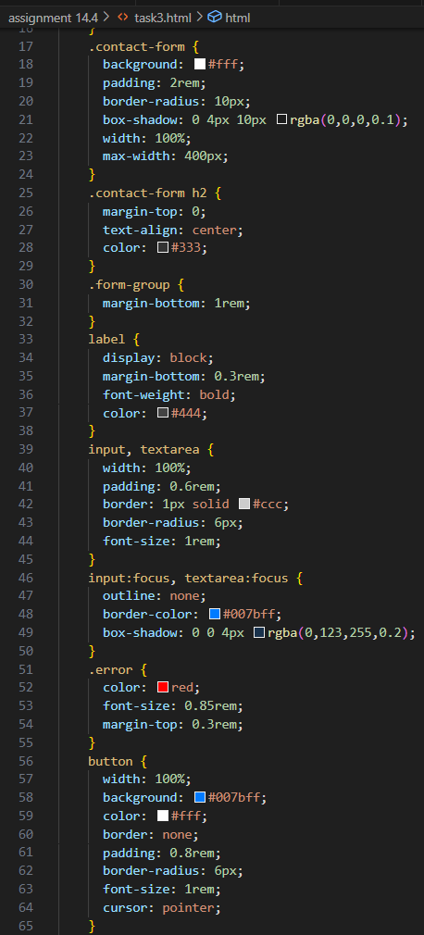

**Output:**

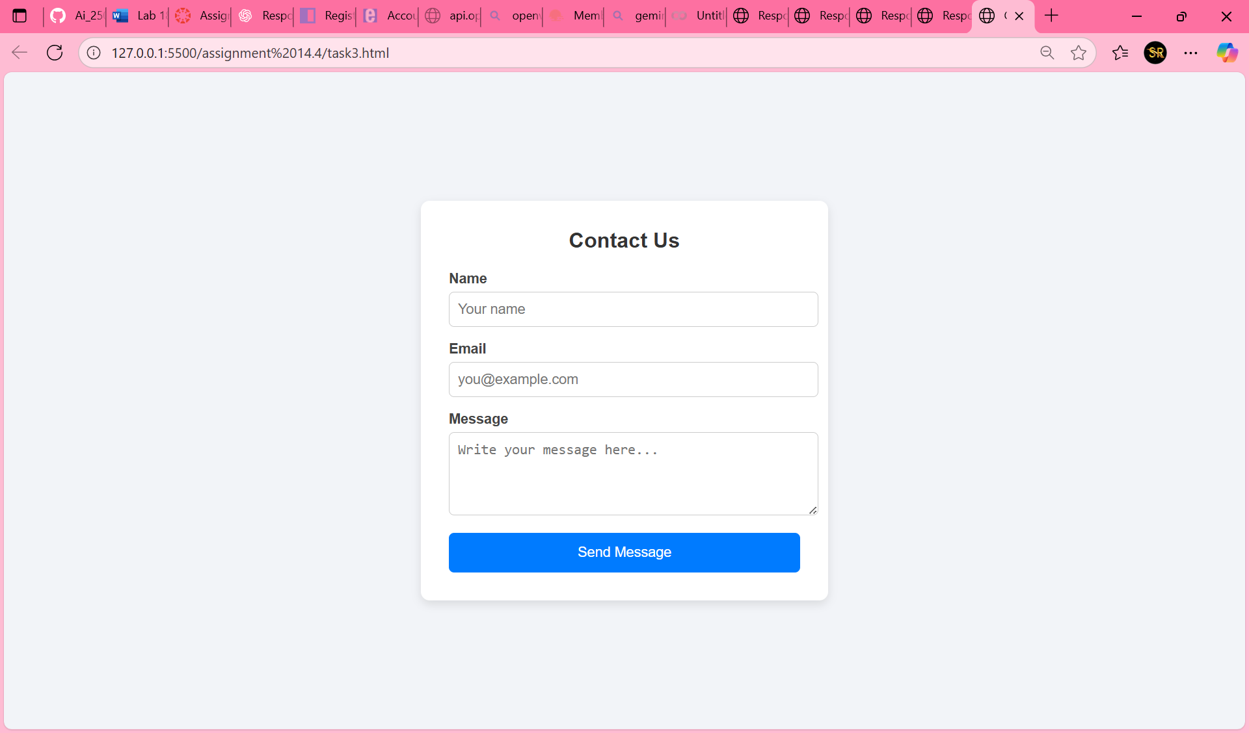

**Observation:**

* The form doesn’t submit unless all fields are correct ,that’s helpful.
* I learned about regular expressions for checking email formats.
* It makes the page feel more professional and user friendly.

**Task 4: Dynamic Content Generation**

**Prompt:**

Create JavaScript that dynamically adds or removes list items from an HTML list when buttons are clicked.

**Code:**

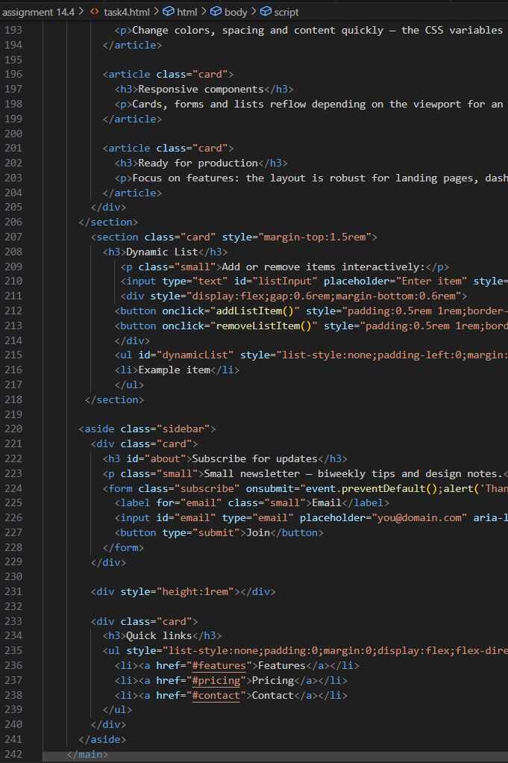

**Output:**

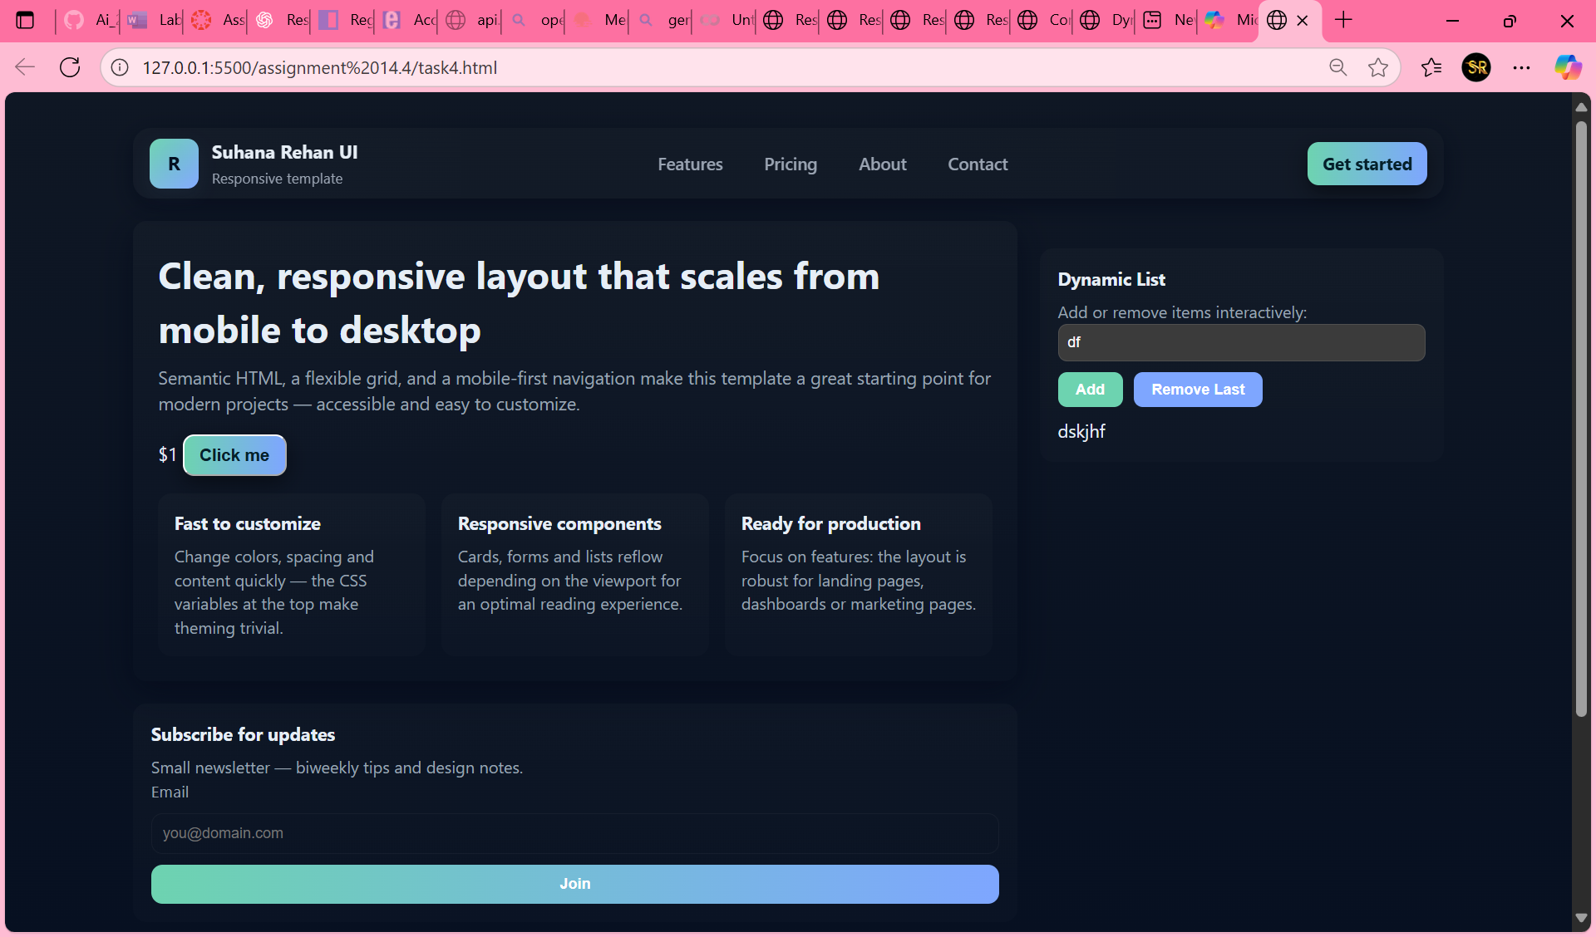

**Observation:**

* Clicking “Add Item” instantly shows a new item ,no refresh needed.
* I learned that DOM manipulation can change web content in real time.
* The appendChild() and removeChild() methods were simple but powerful.

**Task 5: Styled Modal Popup**

**Prompt:**

Generate HTML, CSS, and JavaScript for a modal popup with overlay and close button that opens on button click.

**Code:**

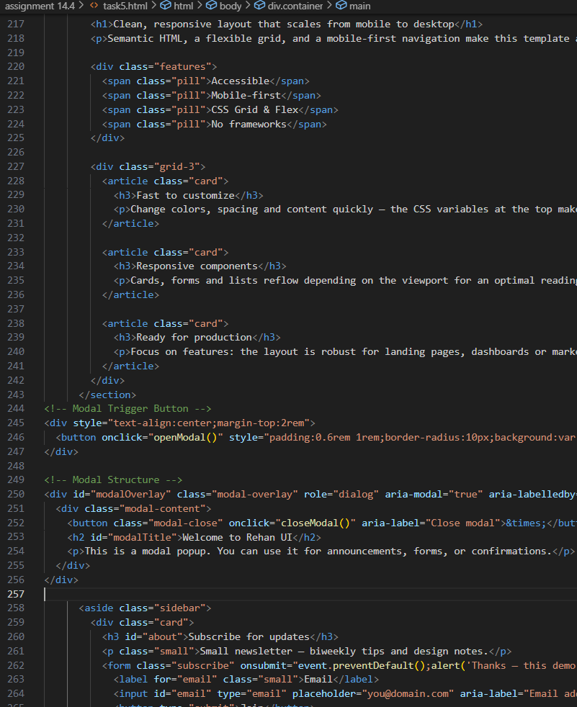

**Output:**

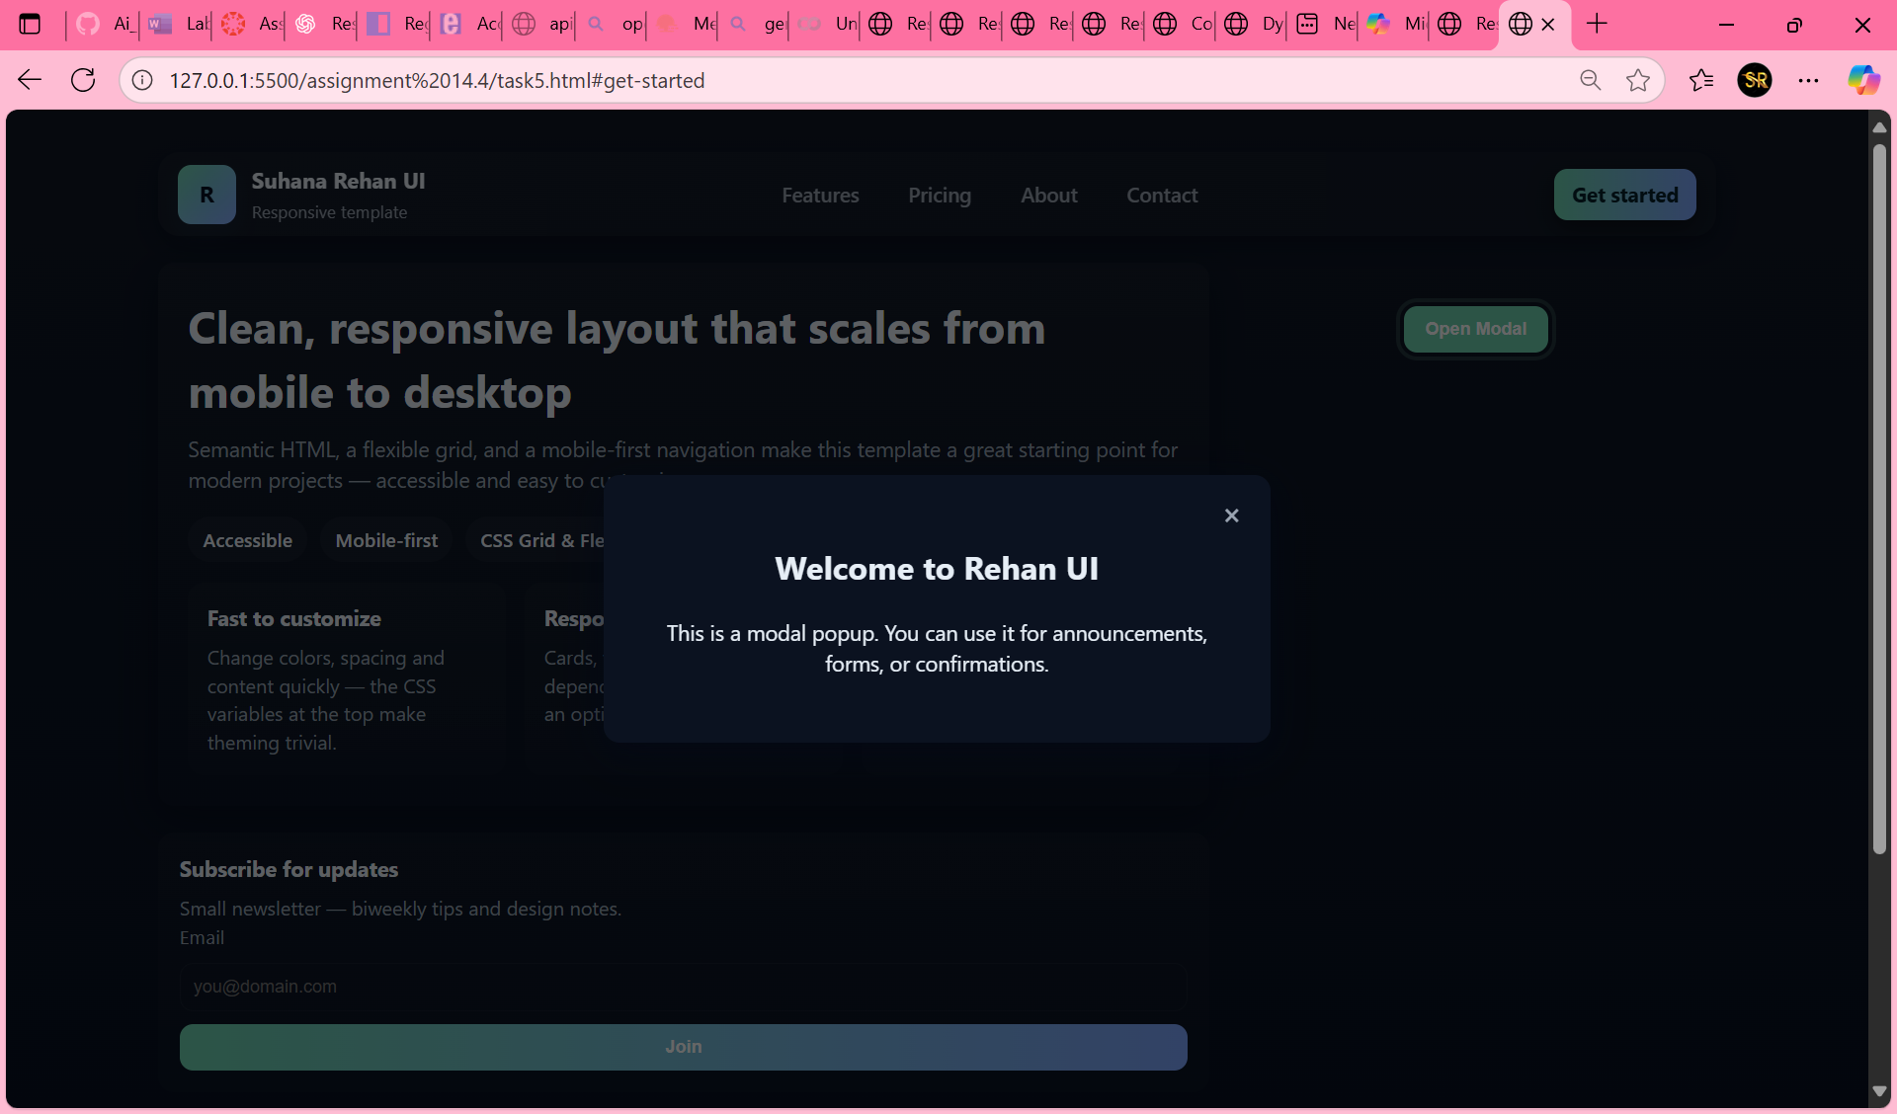

**Observation:**

* The popup appears nicely on top of the page when I click the button.
* CSS overlay makes the background dim and the modal stand out.
* Now I understand how modals can display messages or forms clearly.